1. A travel agent books air holidays for their clients and invoices each client quarterly for cost, deposit paid and balance outstanding. The agent also records flight, hotel and itinerary details (including times).

Which of the following is an entity?

* Holiday code
* Clients
* Time of departure
* Flight 7461

Out of the list, clients are the entity as you can store information on them.

Which of the following would be an attribute of the entity in the above model?

* Client telephone number
* Balance due
* Destination
* Client name

A client’s name would be an attribute of the entity as it’s something you need to know about them.

2. Identify entities that might result from the analysis and data modelling of the processing activities of an estate agent.

Properties they are selling, transactions and sales.

3. The estate agent stores house details by property id in the following table:

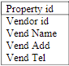Which data items might be repeated? How could some be placed on another table and still related to the property records?

A vendor Name, address and telephone number are data items that might be repeated as it’s possible for multiple people to have the same name.

A vendor id is something that can be placed on another table and still be related to the property records as it’s something unique to only one person.

4. Describe the following relationship in terms of orders and parts.

Instance of Orders list to many parts

5. Draw an ERD to show that many invoices could be sent to 1 customer.

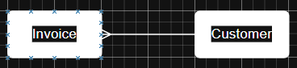

6. At Calderdale College lecturers may teach more than 1 course. Students may also attend more than 1 course. Draw an ERD to represent Students, Courses and Lecturers.

